*****************************************************************************

**Data Warehousing Group Assignment**

**– Chaya Chandana Doddaiggaluru Appajigowda**

**Sean Franco**

**Ujjawal Dwivedi**

*****************************************************************************

**Part 1: Basic Querying and Data Analysis**

**1. List Roads from/to 'Atlanta' with Distances and Destinations:**

**MongoDB:** 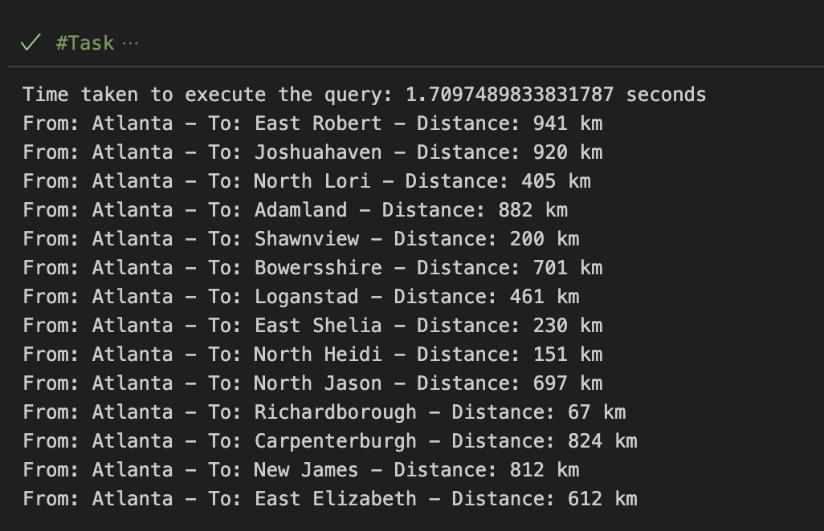

**Neo4j:**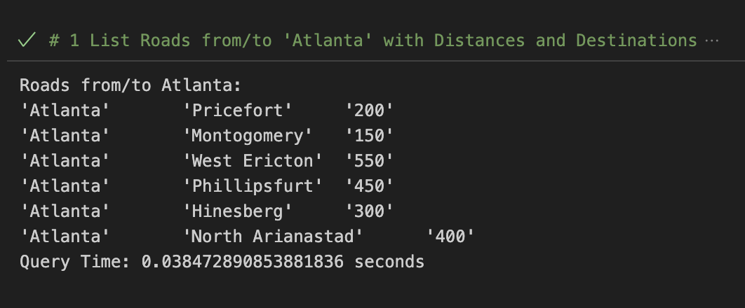

**2. Find Roads Longer than 150 km, with Details:**

**MongoDB:**

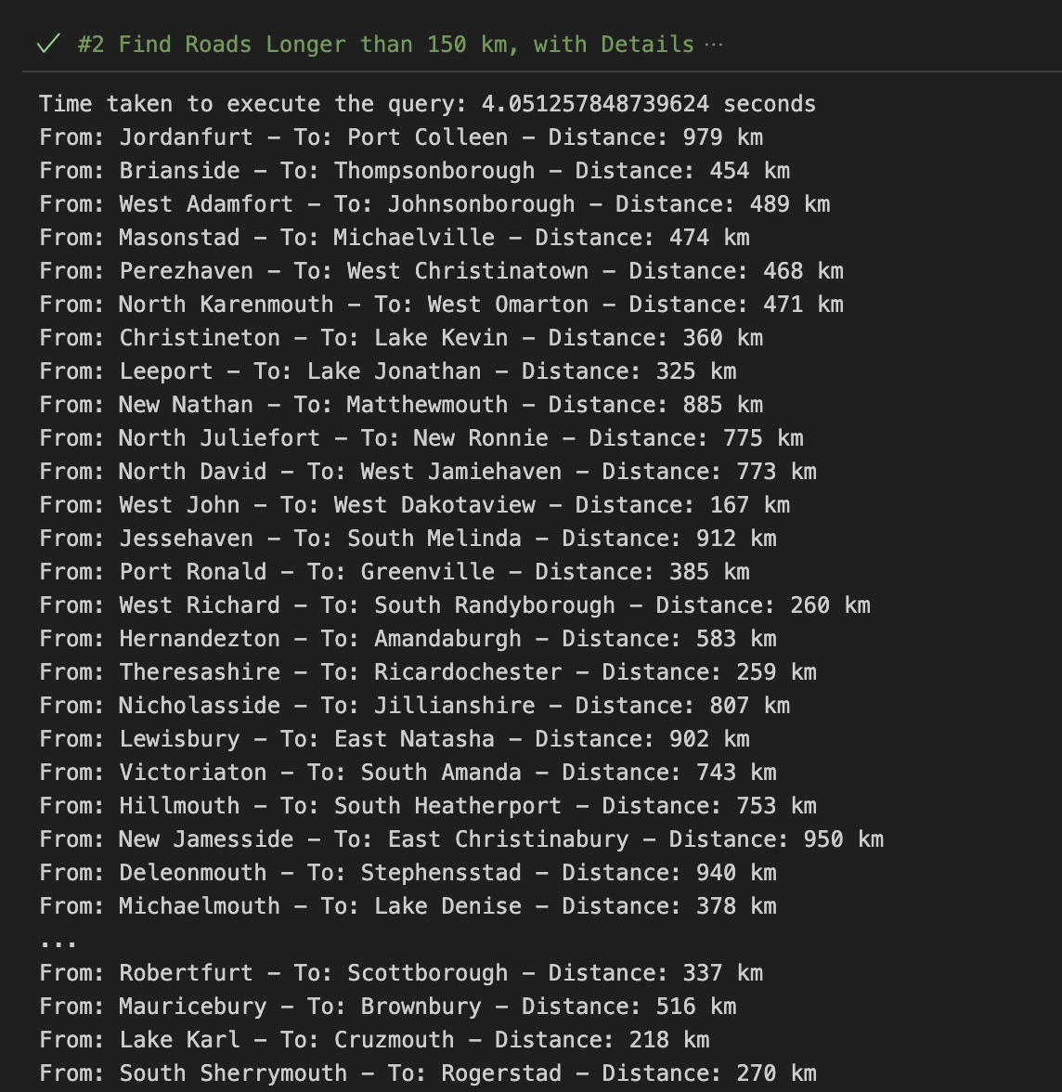

**Neo4j:**

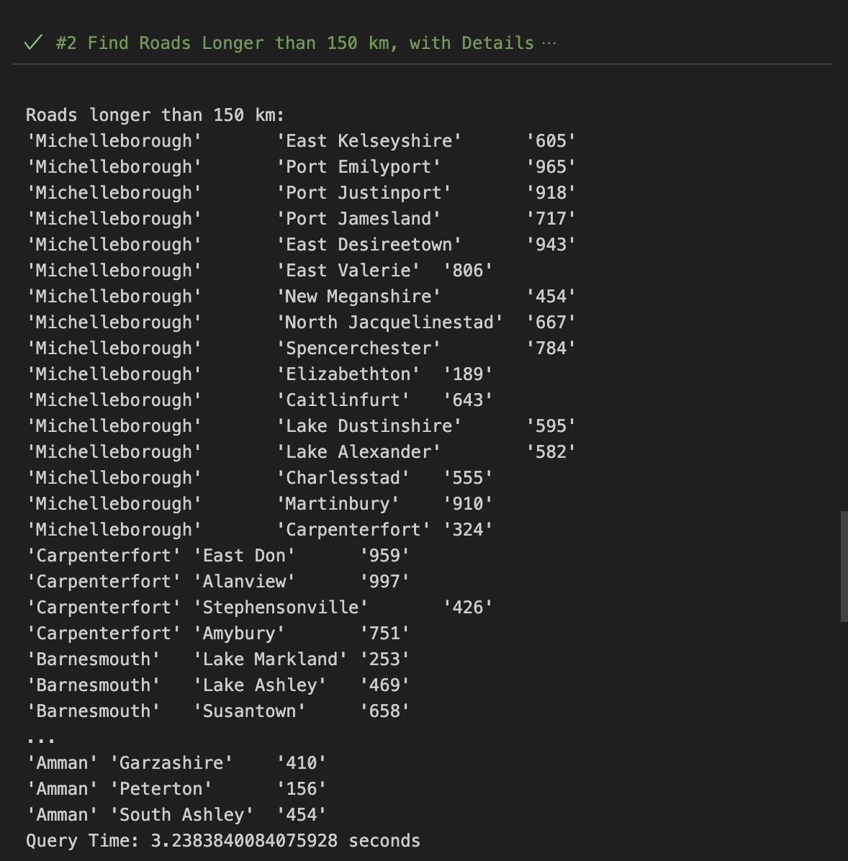

**3. Total Road Length Connected to 'Frankfurt':**

**MongoDB:**

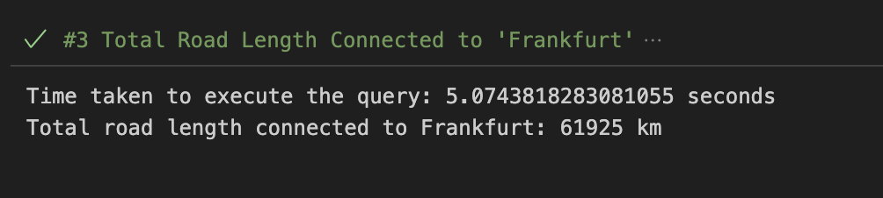

**Neo4j:**

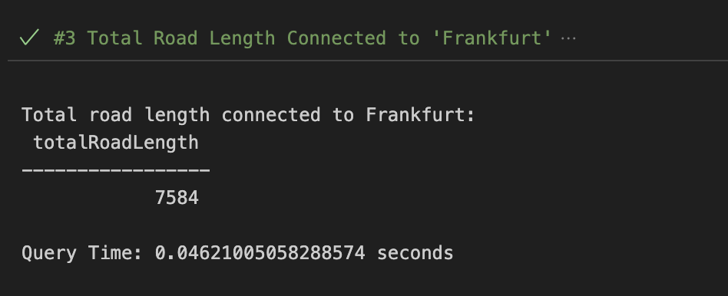

**4. Determine Shortest and Longest Road from 'Amman':**

**MongoDB:**

**Shortest and Longest:**

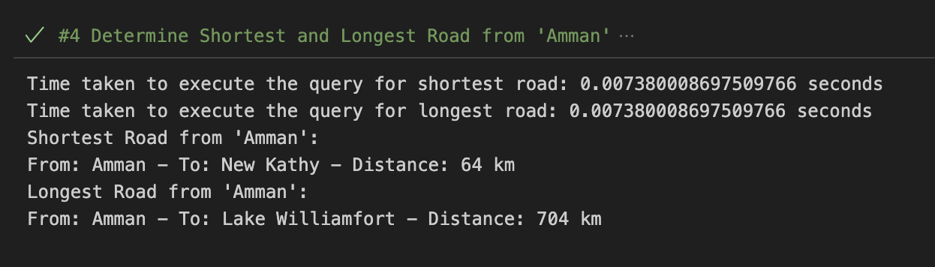

**Neo4j:**

**Shortest:**

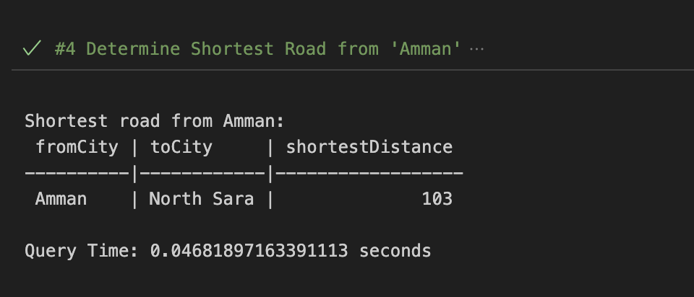

**Longest:**

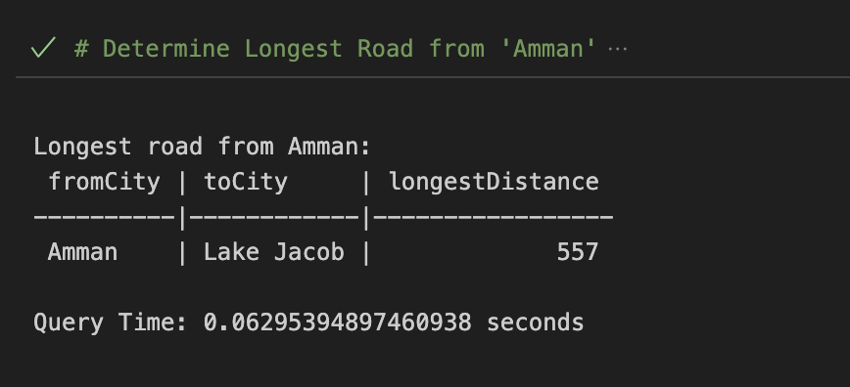

**Time Comparison Between MongoDB and Neo4j:**

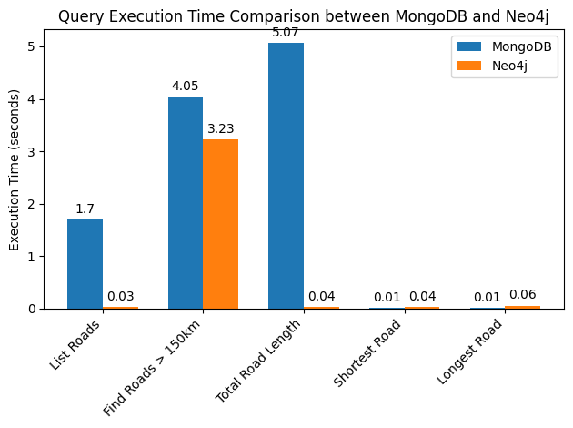

#### **Part 2: Graph Algorithm in Neo4j' Graph Data Science Library**

**1. Depth First Search (DFS):**

**Task 1: DFS from 'Atlanta':**

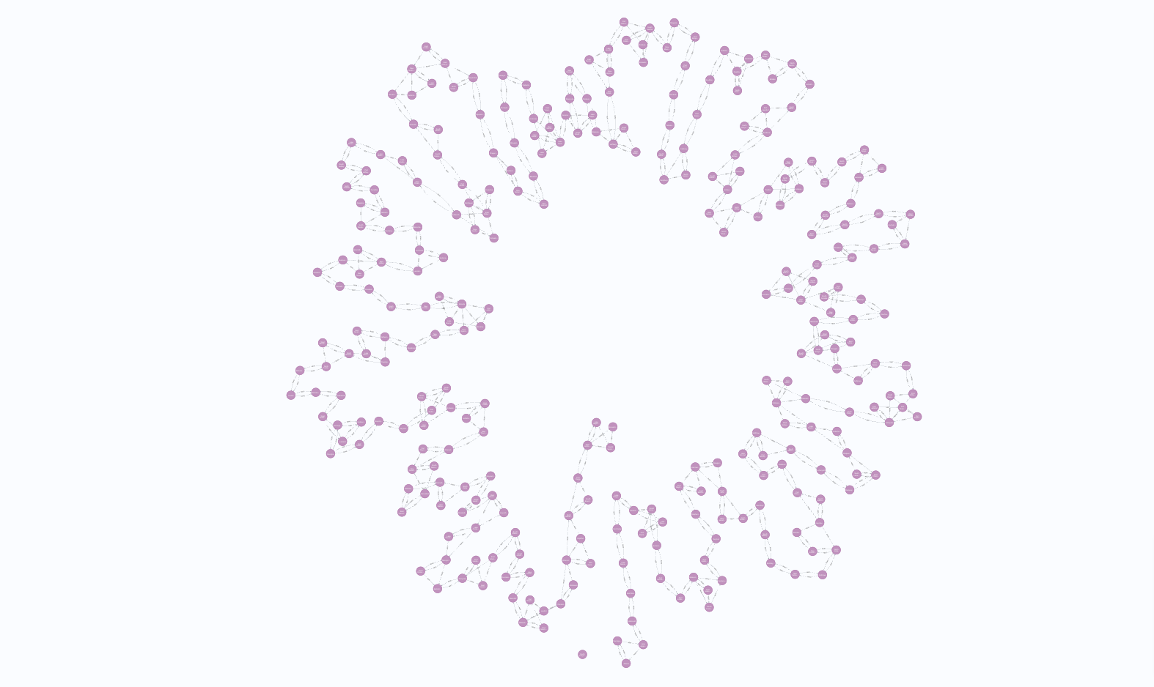**Task 2: DFS from Frankfurt:**

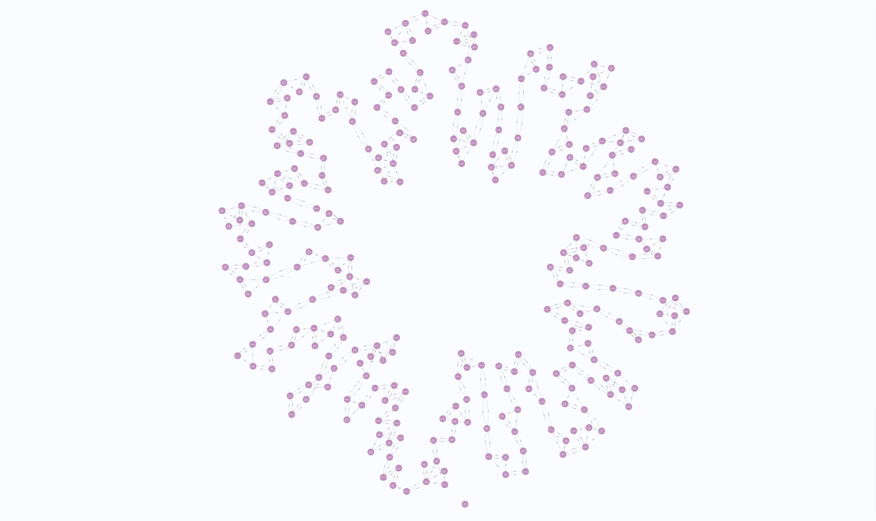

**2. First Search (BFS):**

**Task 3: BFS from 'Atlanta':**

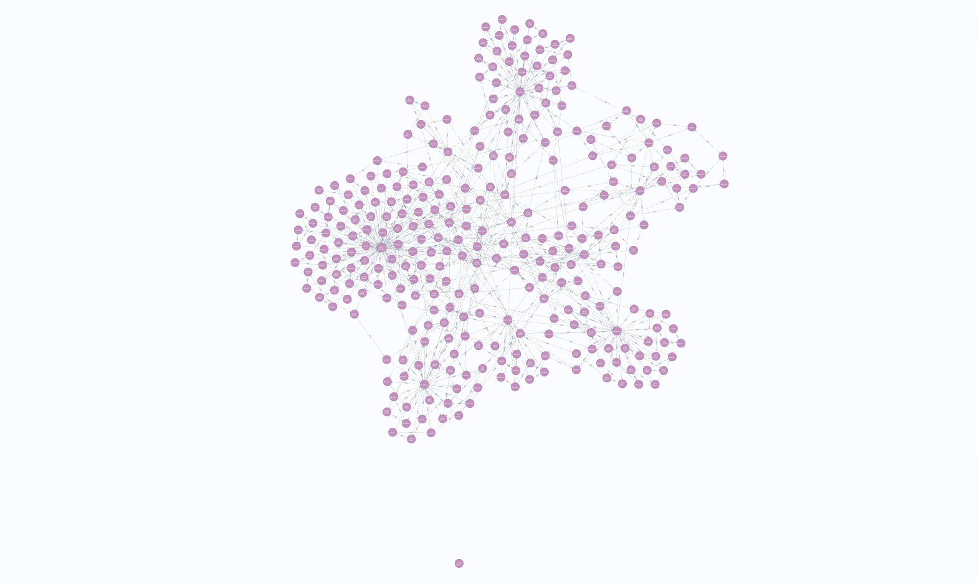**Task 4: BFS from Frankfurt:**

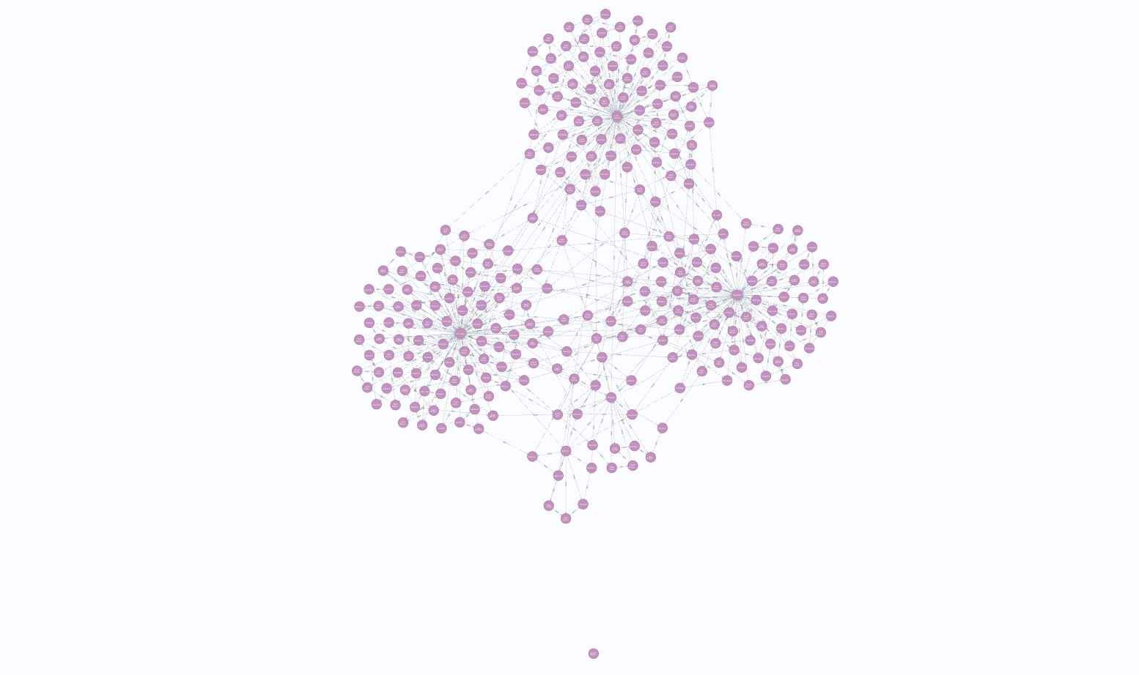

**3. Visualization and Timing Analysis:**

**Task 5.1: DFS Timing and Visualization:**

**Atlanta:**

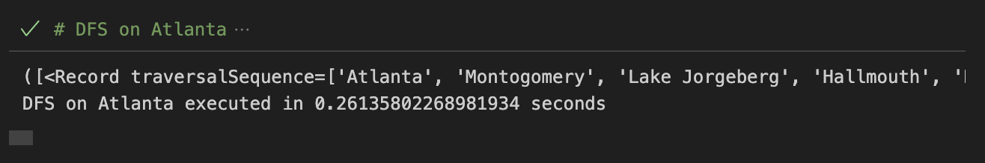

**Frankfurt:**

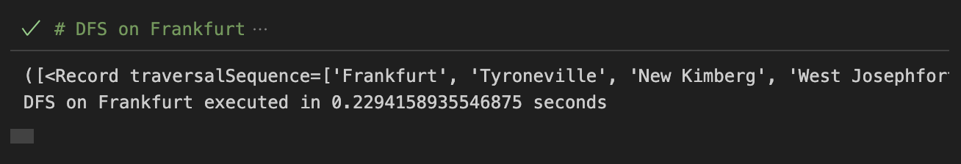

**Task 5.2: BFS Timing and Visualization:**

**Atlanta:**

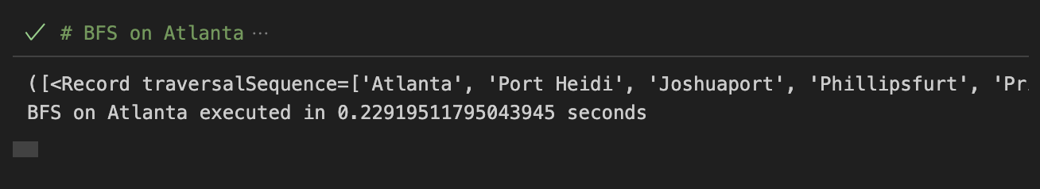

**Frankfurt:**

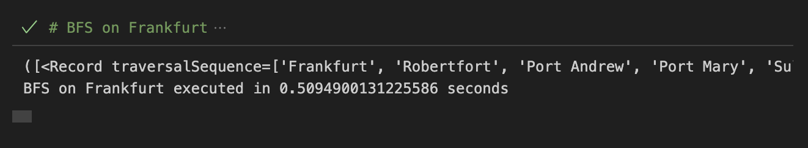

**Task 5.3: Direct DFS and BFS Comparison:**

